**Manage K8s deployment with Ec2 instance.**

1. First **Create Ec2 instance** and **create Key-pair** to **access instance** by ssh-key.

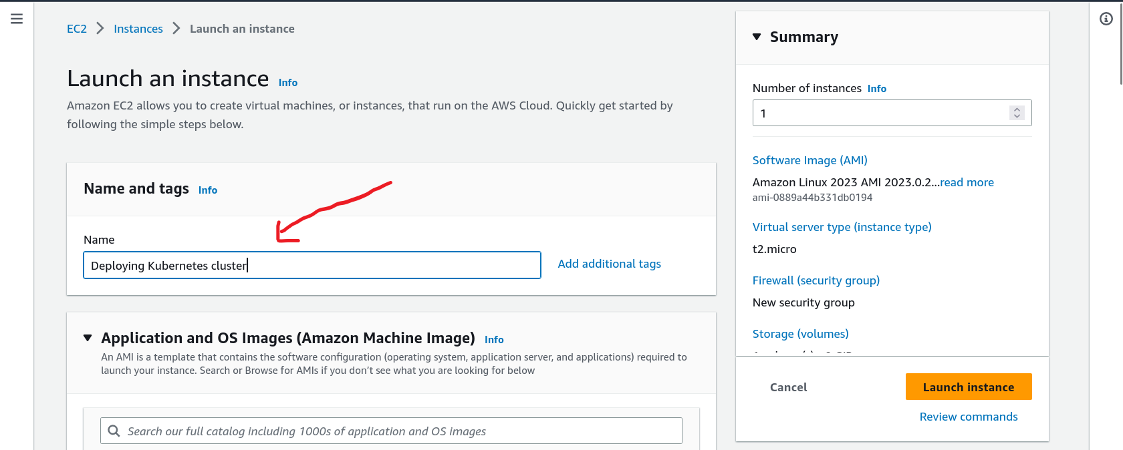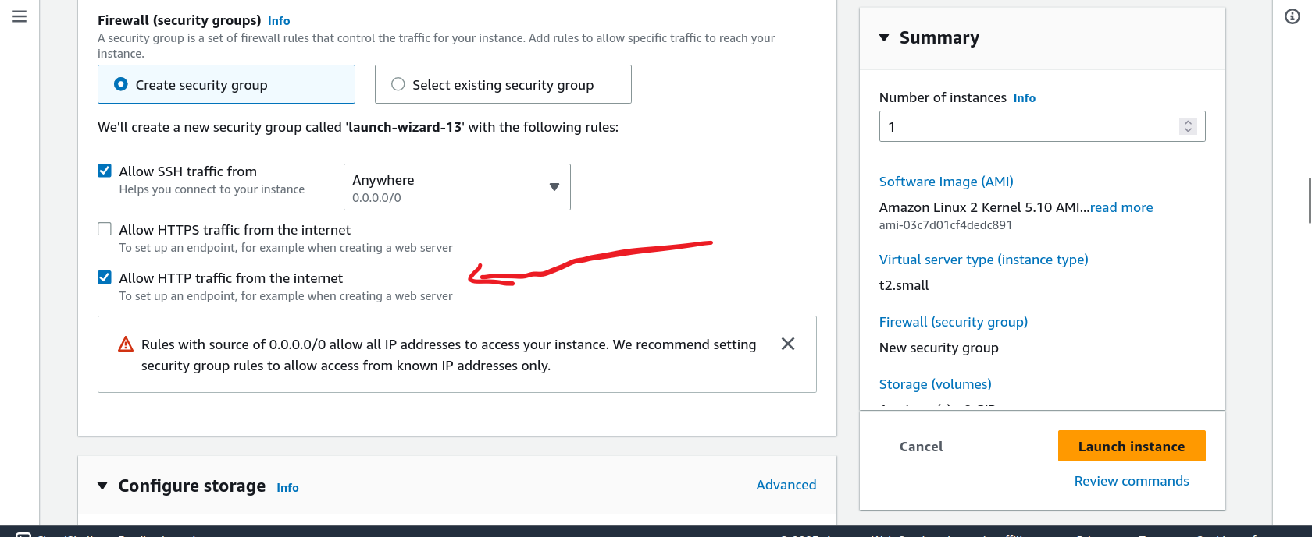

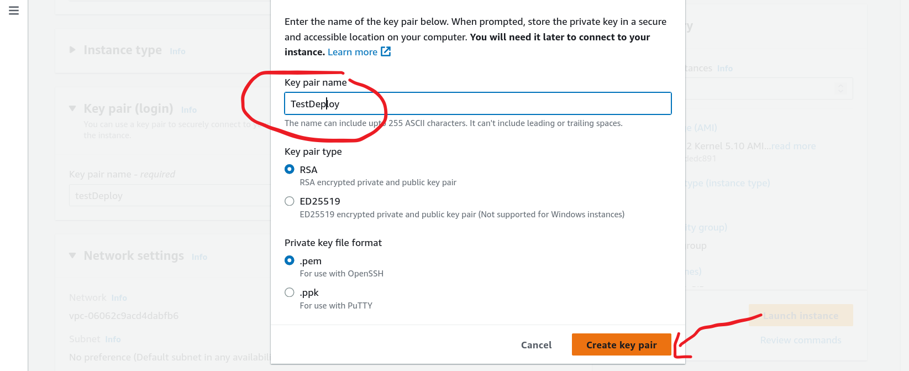

1. **Write this command** to **install** **docker** , minikube ,git and apache-server

1. Now **Acess Ec2** by ssh and check working

1. Run this command to clone the repo and start minikube and install ingress

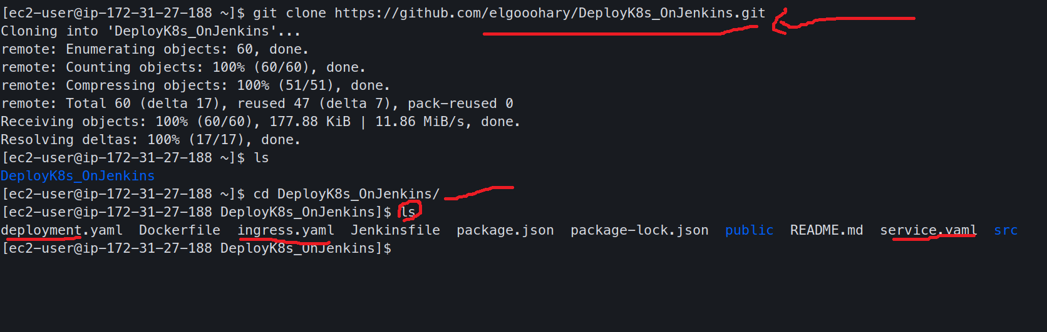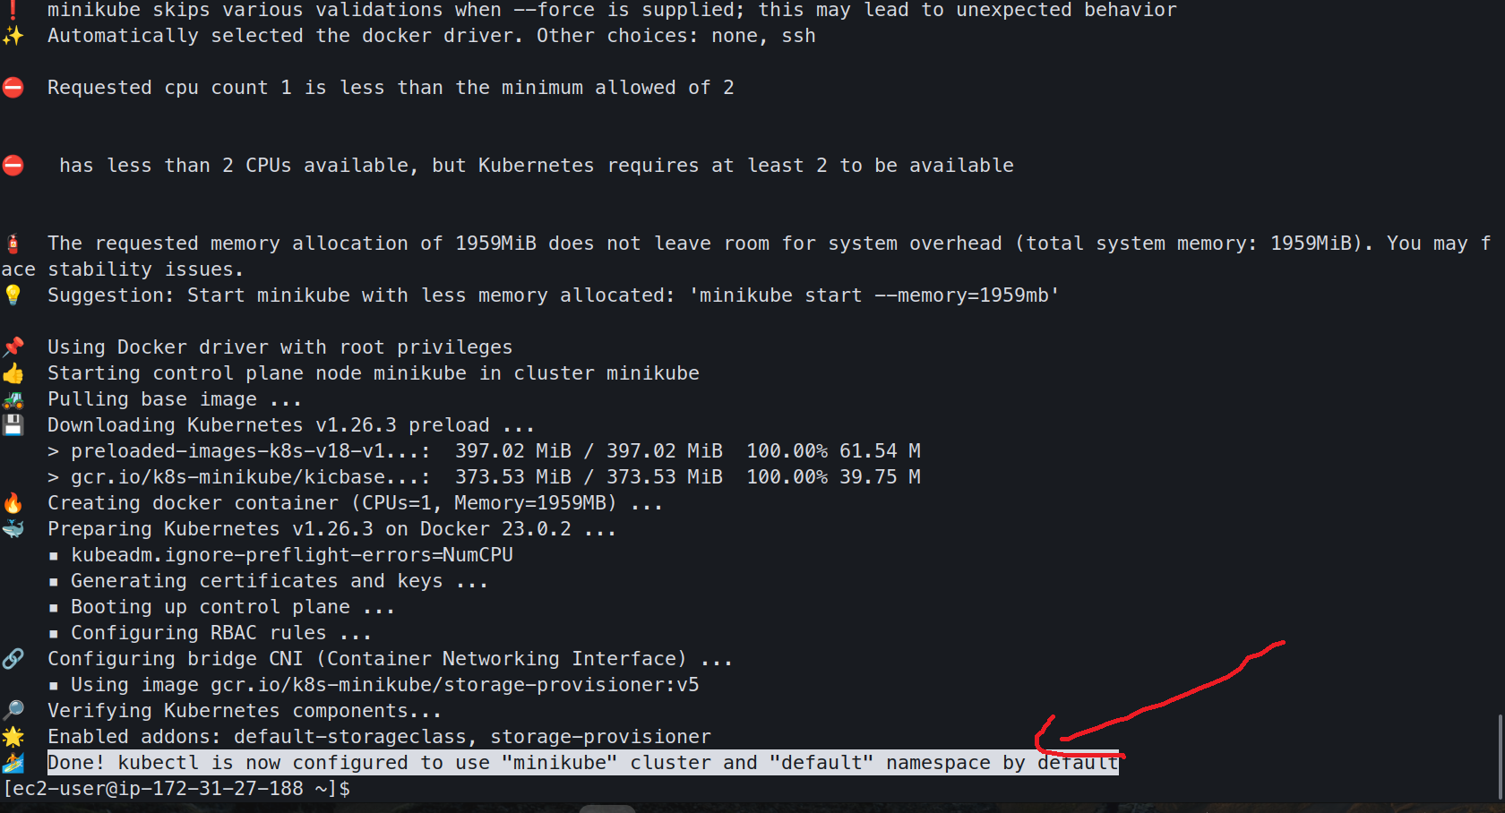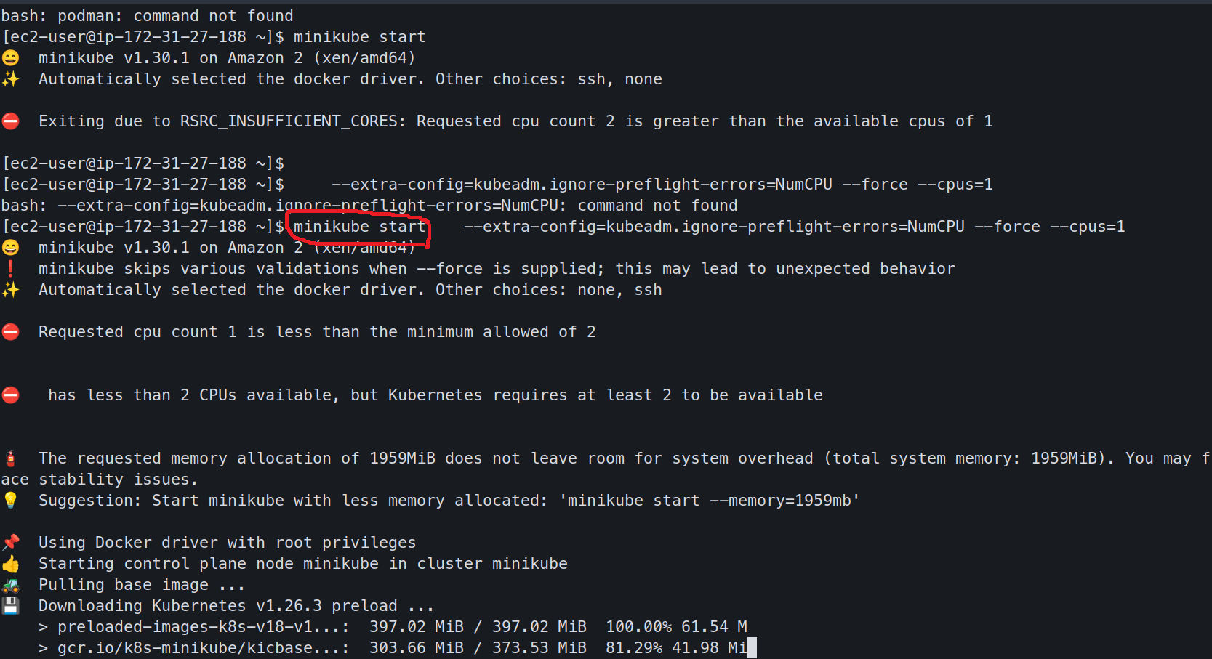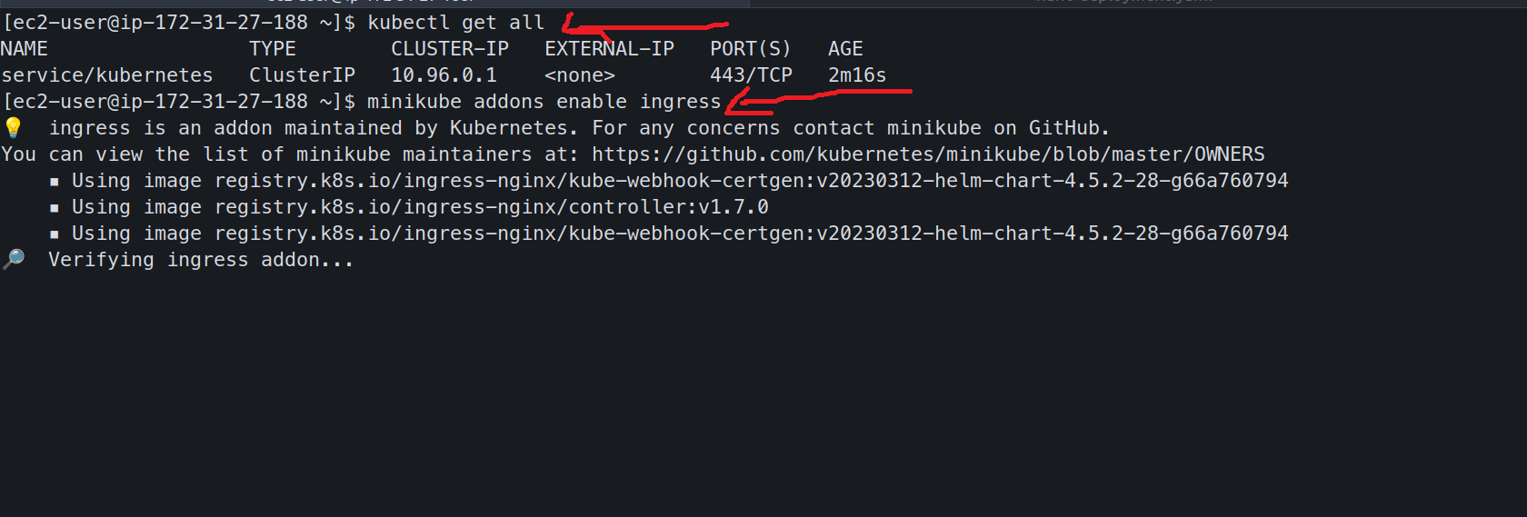

1. Now create deployment,service and ingress by (kubectl apply -f file.yaml)

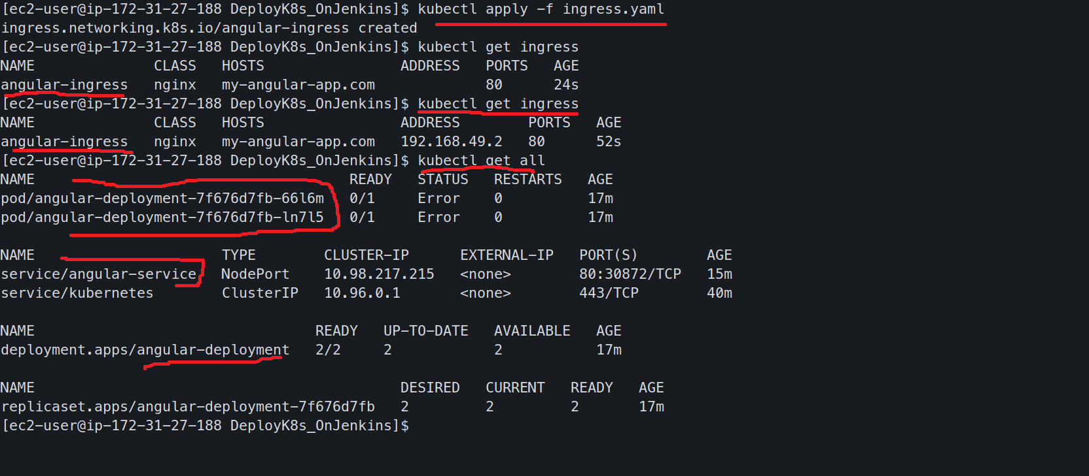

1. Finally test app , run ip for instance and show the result **(http://ip)**

